

Walmart Supercenter
Store #1234
123 Main Street, Anytown, USA 12345
Phone: (800) 555-1234
www.walmart.com

SALES RECEIPT
Transaction Information:
Receipt #: | [XXXXXX]
Date: | [MM/DD/YYYY]
Time: | [HH:MM AM/PM]
Cashier: | [Name]
Register: | [#]
Payment Method: | [Cash / Credit Card / Other]
Items Purchased:
Item Description | Quantity | Unit Price | Total
Milk 1L | [ ] | [ ] | [ ]
Bread Loaf | [ ] | [ ] | [ ]
Toothpaste | [ ] | [ ] | [ ]
Shampoo | [ ] | [ ] | [ ]
Bananas (1lb) | [ ] | [ ] | [ ]

Subtotal: $[ ]
Tax (7%): $[ ]
Total Amount: $[ ]

Return Policy
- Items may be returned within 90 days with a valid receipt.
- Electronics and select items may have shorter return periods.
- Items must be in original condition and packaging.
- Refunds are issued to the original method of payment.

Contact Us
For any inquiries or feedback, please contact Walmart Customer Service at (800) 555-1234 or visit www.walmart.com/help.

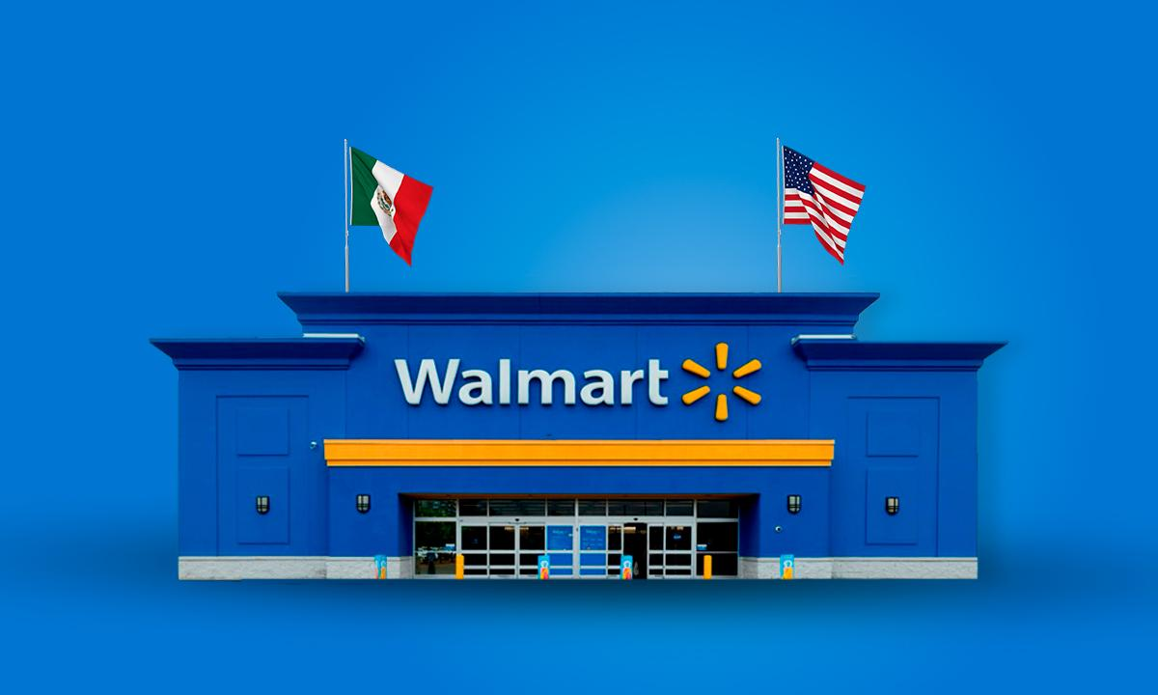
Thank you for shopping at Walmart!

